***DryHireUK***

CALL NOW

***We are a specialist dehumidifier hire company, providing a first class service with the latest high performance machines.***

* ***Same day / Next Day Delivery***
* ***Competitive Rates***
* ***Reliable Friendly Service***
* ***All Major Credit Cards Accepted***

***Please take a look at our current range below and give as a call for an immediate hire.***

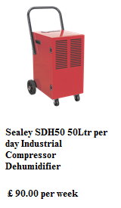 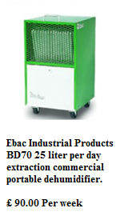 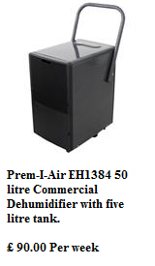 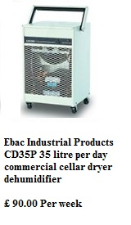

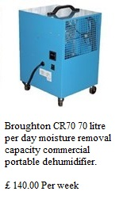 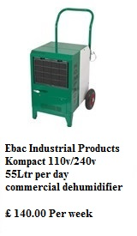 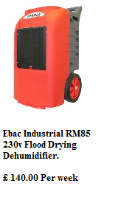

***Contact us now on :***

***TEL: 0117 9095727***

***Mob: 07903801031  
Mob:*** **07966 487504**Web: **www.dryhireuk.com**